Week Two – Assignment 1 – Front End Analysis
Helen Ngo
EDF 6284

Goal: Employees will be able to operate a lawn-mower and mow a lawn.
Need Analysis
- What is the need for your educational product? – To hire new employees and to match their skills with the current job description is to perform a research within the company and focus on employee’s performance and customers’ feedback survey. Based on the information, we will come up with the solid plan for new hire employees.
- For current employees, I will look into their training record including Computer Based Training (CBT) to see if they meet all the requirements or not. I will collect all the information and determine who will need to do the trainings. I also look into equipment availability issues, customers’ feedback, and technical issues. Once I collect record, I will consult with project sponsor to determine whether to determine to hire new employees or not.
- For those who are new to computers, a computer based training (CBT) would be required. Having them attending a training class and presenting tutorials in a computer with a PowerPoint presentation or an interactive video would help novices to recognize the important of how to perform a job or job safety. Any type of visual aids provides are helpful. Also, the training specialist could teach them how to use computer to enter their working-hours in a timesheet by using a Microsoft Excel spreadsheet, and demo the lawnmower unit in step-by-step (see flow chart).
- An anonymous survey will send out to current clients and workers that I would recommend for the Needs Analysis because this would help to collect the statistics and to see how the company currently performs. Also, an observation will take place by sending someone to examine how the current employees achieve their daily job. In addition, having an interview with each existing employee (to see if they encounter any difficulties when mowing the lawn) or customers (in term of services) would help to collect real data.
- There are several steps that I’d use to obtain information on the potential need for the project, including the following:
- I will get the information from current customers and employees and the owner of a lawn company.
- I will get it through survey, observation, interview or focus group.
- I will analyze the information by documenting all the details that I receive from clients and workers and running a statistic report to find out who need trainings or not – focus on the percentage in graphical format.
- Once I gather all the necessary information, I’ll create a statistical report including graphical interface to see what the jobs is suitable for the new employees.

- After analyzing these data, I feel that some of the concepts discussed in class such a Needs Assessment Process flowchart from Kemp model below is related to this Needs Analysis assignment.
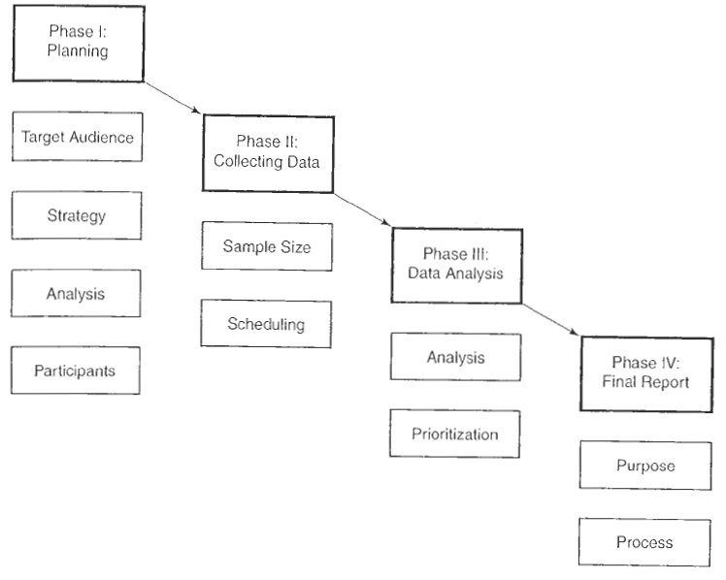
Action

Results

- There are several factors (other than training) might be responsible for poor performance such as employees showing up late at work (tardy), attitude on performance, issues on equipments, injuries, and the timelines of the projects – not meet the deadline.

- Assess the Target Audience (learner)
My target audiences are males ranging from 16 to 65 years old. My focus is to select males’ participants because they are considered to be stronger and responsible for lawn care than women. I’m assuming I will hire 10 newly employees. 20% of these could be high school kids with cognitive characteristics such as good aptitude, able to read and write, and having knowledge in computer. This could be beneficial for the training specialist when is come to have a CBT because these kids could help their co-workers in a training class. 40% of audiences would be in the mid-forty with physiological characteristics who are healthy, hard-working and able to perform the job professionally; these men could be focusing on mowing the lawn. I also will look for 30% of individuals who are 50 to 65 years old with affective characteristics such as interesting, motivating and good attitude toward learning new things. They could encourage other workers to finish their job on time. Lastly, 10% left would be someone in his thirty with social characteristics such as having good relations to peers, having feelings toward authority and good in communications to advertise and promote the mowing lawn services.

- Conduct a Goal/ Task Analysis
The picture of a lawn mower below is similar to the one that my father owns at home.

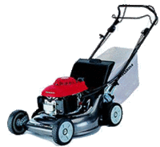
How to mow a lawn?

Purchase the lawnmower
Gasoline or Electric
Electric Lawn Mower
Gasoline Lawn Mower \\Mower
Wear proper protection!
STOP
Add proper gasoline and oil mixture
Pull the cord – if not start, try again!
Mow in rows or columns, going all the way to the other side and then turning around. Check for missed spots, mow again if necessary!
Plug the cord to extension cord connected to the power inlet
Check for proper power indicator – red, blue, orange
Press the power button – if not start, try again!
In case if the blade got stuck, press stop button, and use water to wash off wet grass or debris on the blade, and continue to mow!
Visual Check to see all the grasses are evenly cut. Repeat the steps if necessary!

